(Approx. 238 words)

Windows 7 Program Compatibility Mode
By Lynn Page, Editor, Crystal River User Group, Florida
April 2012 Newsletter
http://crugdotcom.wordpress.com/
lpage (at) tampabay.rr.com

Program Compatibility Mode allows you to run programs writ ten for earlier versions of Windows. If an old program doesn't run correctly, use the Program Compatibility troubleshooter to simulate a version of Windows that it ran well on.
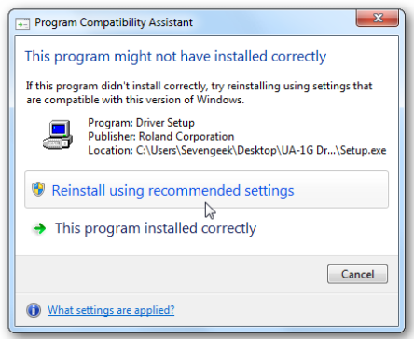
Problems Installing a Program
The Program Compatibility Assistant detects compatibility issues when trying to install a program that does not support Windows 7. If a compatibility error is found during installation, after closing the error message, the Program Compatibility Assistant notifies you that the program might not have installed correctly. It prompts you to Reinstall using recommended settings.

Program Compatibility Troubleshooter
Some programs install, but don’t work properly with Windows 7. The Program compatibility troubleshooter may solve the issue. Or right click the program icon and select Troubleshoot compatibility. In search box type Program compatibility troubleshooter and select it. Click Next, select the program from the listing and then select Try recommended settings.
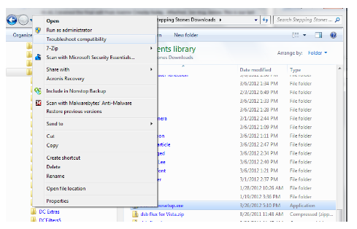

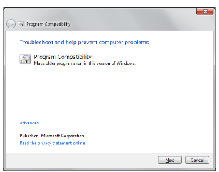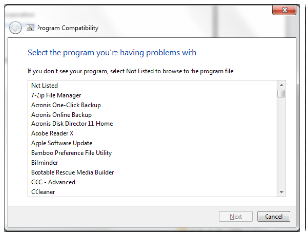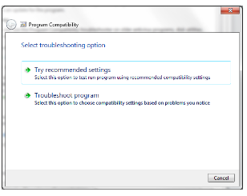

Manually Select Compatibility
You can bypass the Program Compatibility troubleshooter and manually set the Compatibility Mode. Right click the program icon and select Properties. Select the Compatibility tab and check Run this program in compatibility for: In the drop down
list select the version of Windows that the programs runs on. Then the program will always run in Compatibility Mode for the version of Windows selected.

